# How many daily calories should I consume?

Source MedicalNewsToday, by Health Canada.

Where “Active level” means 60 minutes of moderate activity each day

Male(left) and Female(right)

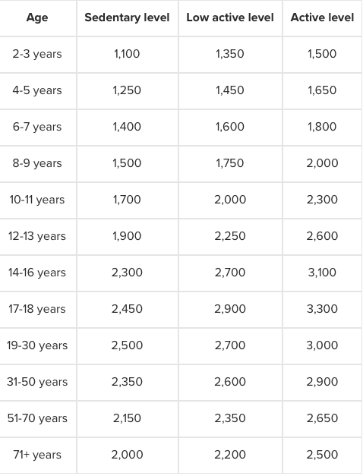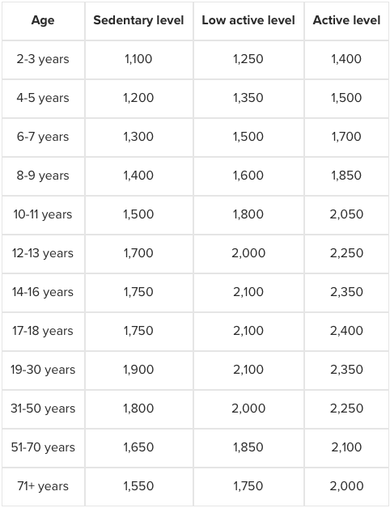

# I should eat 3000 calories per day. Where do I get them from?

**Age 2-3 years**: Fruit and vegetables 4, Grains 3, Milk (and alternatives) 2, Meat (and alternatives) 1.

**Age 4-8 years**: Fruit and vegetables 5, Grains 4, Milk (and alternatives) 2, Meat (and alternatives) 1.

**Age 9-13 years**: Fruit and vegetables 6, Grains 6, Milk (and alternatives) 3-4, Meat (and alternatives) 1-2.

**Age 14-18 years (male)**: Fruit and vegetables 8, Grains 7, Milk (and alternatives) 3-4, Meat (and alternatives) 3.

**Age 14-18 years (female)**: Fruit and vegetables 7, Grains 6, Milk (and alternatives) 3-4, Meat (and alternatives) 2.

**Age 19-50 years (male)**: Fruit and vegetables 8-10, Grains 8, Milk (and alternatives) 2, Meat or alternatives 3.

**Age 19-50 years (female)**: Fruit and vegetables 7-8, Grains 6-7, Milk (and alternatives) 2, Meat (and alternatives) 2.

**Age 51+ years (male)**: Fruit and vegetables 7, Grains 7, Milk (and alternatives) 3, Meat (and alternatives) 3.

**Age 51+ years (female)**: Fruit and vegetables 7, Grains 6, Milk (and alternatives) 3, Meat (and alternatives) 3.

# What’s the size of the serving?

* **Fruit and vegetables**: 1 piece of fruit, half a cup of fruit juice, half a cup of canned or frozen fruit or vegetables, 1 cup of leafy raw vegetables or salad
* **Grains**: Half a bagel, 1 slice of bread, half a tortilla, half a pitta, half a cup of cooked couscous, rice or pasta, one ounce of cold cereal, three-quarters of a cup of hot cereal
* **Milk and alternatives**: 1 cup milk, 1 cup of soy drink, three-quarters of a cup of yogurt, 1 and a half ounces of cheese
* **Meat and alternatives**: 2 and a half ounces of cooked fish, lean meat, poultry or lean meat, 2 eggs, 2 tablespoons of peanut butter

# Constraints on consumption

**Consuming fruit and vegetables:** Experts say you should consume at least one dark green and one orange colored vegetable each day. Examples of dark green vegetables include spinach, [kale](https://www.medicalnewstoday.com/articles/270435.php), and broccoli.

Go for fruit and vegetables with either no sugar, salt, or fat, or at least as little as possible. It is recommended to steam, bake, or stir fry the vegetables. Limit or avoid foods that are deep fried. Whole fruit and vegetables are a better choice than their juices, as they provide more nutrients and fiber. They are also more filling which can deter overeating.

**Consuming grains:** Health authorities say we should aim for whole grains for at least half our grain consumption. Go for variety, including wild rice, [quinoa](https://www.medicalnewstoday.com/articles/274745.php), oats, brown rice, and barley. Whole grain pasta, oatmeal, and breads are better than those made from refined cereals.

A good grain should not have a high sugar, salt, or fat content. Alternatives to grains that contain many of the same nutrients are beans, legumes, quinoa, and starchy vegetables like sweet potatoes and peas.

**Consuming milk (and alternatives):** Consume 2 cups per day for good [vitamin D](https://www.medicalnewstoday.com/articles/161618.php) and [calcium](https://www.medicalnewstoday.com/articles/248958.php)intake. If you don't drink milk, have fortified drinks. Limit your intake of milk with added sugars and other sweeteners. Low-fat milk may be recommended if you are limiting your total fat or saturated fat intake for heart health reasons.

**Meat and alternative:** Make sure you are eating alternatives, such as tofu, lentils, and beans regularly. It is recommended to have fish at least twice a week. Beware of certain types of fish for mercury exposure. Opt for lean meats, such as chicken or [turkey](https://www.medicalnewstoday.com/articles/285736.php).

Rather than frying, try roasting, baking, or poaching. If you are eating processed or prepackaged meat, select low-salt and low-fat ones. Limit your overall intake of processed meats since you may have an increased risk for [cancer](https://www.medicalnewstoday.com/info/cancer-oncology/) with regular intake.

When eating [carbohydrates](https://www.medicalnewstoday.com/articles/161547.php), choose unrefined carbs, such as whole grains, which are high in fiber and release energy slowly, so that you feel full for longer.

Limit saturated fats and avoid trans fats as much as possible. It is recommended to consume not more than 10 percent of your total calories from saturated fat. Plant oils, fish, and nuts are the best sources. Make sure to get plenty of fiber. When eating fruit and vegetables, eat a variety of colors. If you are not a great milk-drinker, make sure your consumption of calcium is adequate.

If your main concern is to know how much food you should eat, you still have to be aware of their calorie values. With high-calorie foods, the quantity will have to be less, while with lower-calorie ones you can eat more.

Sophia tips

people can select their food preferences and highlight their dislikes

then you would have a database of recipes with relevant calories info

so it could put the right recipe in your schedule

with foods you will like or often eat

if you want to be really advanced you can connect to food prices

to give a cost estimate

or range >

do you like it?

ask them which supermarket they shop at

then form partnerships with them

and generate commission when ordered thorugh our platform

type of diet for protein: Source random website

Paleo

Atkins

Zone

Dukan

In the UK, adults are advised to eat 0.75g of protein for each kilogram they weigh, based on the Reference Nutrient Intake (RNI). So if you weigh 70kg (11 stone), you should eat about 52.5g of protein a day.

**How can I tell if a food is high in fat, saturated fat, sugars or salt? Source NHS**

**Fat**

**High in fat:** more than 17.5g of fat per 100g   
**Low in fat:** 3g of fat or less per 100g

**Saturated fat (saturates)**

**High in saturates:** more than 5g of saturates per 100g   
**Low in saturates:** 1.5g of saturates or less per 100g

**Sugars**

**High in sugars:** more than 22.5g of total sugars per 100g   
**Low in sugars:** 5g of total sugars or less per 100g

**Salt**

**High in salt:** more than 1.5g of salt per 100g   
**Low in salt:** 0.3g of salt or less per 100g

Idea

Create a platform where nutritionist competes as they are chosen directly from the clients. The clients join the platform and insert they basic data. The outcome is a diet made for them. The output is how many meal per day and what to eat in it. It includes the exact number of calories they need. Include also cheat Friday.

We connect the groceries to the clients, as we select their products and bring it to the clients through outsourcing like ubereeat. We ask commissions to groceries and we ask commissions to ubereat. We ask commissions to the nutritionist that advertise their ideas. The app is for free. But there is a premium that account that follow the client step by step, direct contact and talk with nutritionists.